**What is the difference between English Literature and American Literature?**

• Literary works written and published in Great Britain and British colonies are referred by the term English literature while American literature refers to literary works written and published in America.

• English literature is written in British English while American literature is written in American English.

• American literature is often known as a much more realistic in portraying characters while English literature is known for its wit and portrayal of theme in plots and characterization.

**AGE**: **The origin of the American literature** dates back to the early 17th century. American literature was largely shaped by the history and development of the country and revolutionary ideas emerged during civil war “Gone with the Wind” by Margaret Mitch, revolutionary wars, slavery “The Adventures of [Huckleberry Finn](https://freebooksummary.com/mark-twains-satire-in-huckleberry-finn-1590)” by Mark Twain.

. America, originally being a British colony, was part of English literature until the country won independence and every aspect of the country: economy, education, literature, arts, culture, and social aspects changed and new brands brooded. [**English literature**](https://www.internationalstudent.com/study-literature/what-is-english-literature/) **emerged** in the 10th century. The English style is therefore considered richer in this respect.

**LANGUAGE**: British writers tend to use classical British English; their vocabulary is richer. On the contrary, the language of an American writer is simultaneously simpler and more accessible. This language is more modern than original British English.

**STYLE:** American literature is to be focused on politics, economics, and social status. Satire, sarcasm, and cynicism can be also often found. On the contrary, British literature of the same period mostly invokes romance, human values, ideals, and manners. British writers’ works come “from the heart,” while American writers are more cool-headed and cynical.

**English**: William Shakespeare, Jane Austen, Charlotte Bronte, Virginia Woolf, William Wordsworth, W.B. Keats, Robert Frost, Lord Byron, Kipling, Dickens, Rowling, Tolkien, Orwell, and Collins.

**American writers** like J. F. Cooper, J.D. Salinger, Jack London, E.A. Poe, Mark Twain, Scott Fitzgerald, W. Faulkner, Flannery O’Connor, Ernest Hemmingway, and Stephen King

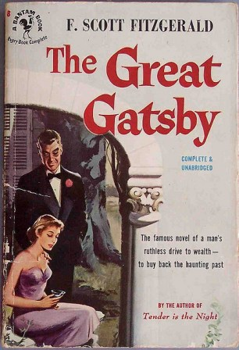

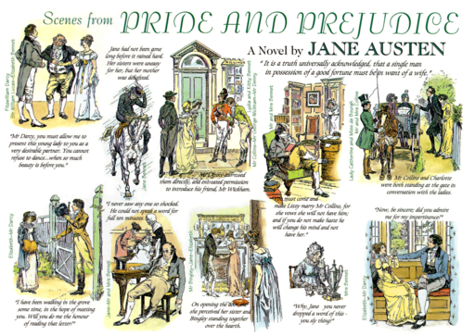

## What is English literature?

English literature refers to the collection of written literary work in the Great Britain and its colonies since the 7th century to the present day. As may be apparent, it has a great and much-loved history where it is chronologically categorized into several eras: Old English literature (c.658-1100), Middle English literature (1100–1500), English Renaissance (1500–1660), Neo-Classical Period (1660–1798), 19th-century literature, English literature since 1901 which includes modern, post-modern, and 20th century literature. Among the many writers from different parts of the English speaking world, those who have immensely contributed to the development of English literature are, William Shakespeare, Jane Austen, Charlotte Bronte, Virginia Woolf, William Wordsworth, W.B. Keats, Robert Frost. As literature is the presentation of writers’ expressions towards life in their socio-economic background, any type of literature depicts a certain culture. English literature, by its all forms, genres, and stylistics, reflects the culture of the British. The most known features of English literature include its wit, depiction of manners, disparity between classes, themes being stressed on plots and characterization.

## What is American Literature?

Comparatively, American literature is a notion that emerged in the recent past. It is the production of literary work written in the context of America portraying American culture and themes. America, originally being a British colony, was part of English literature until the country won independence and every aspect of the country: economy, education, literature, arts, culture, and social aspects changed and new brands brooded. The origin of the American literature dates back to the early 17th century. American literature was largely shaped by the history of the country and revolutionary ideas emerged during civil and revolutionary wars.

## History

National literature is connected with national history. As we all know, English literature emerged earlier than American literature, since America was a British colony.

Therefore, while American literature’s history dates back to the 17th century, [English literature](https://www.internationalstudent.com/study-literature/what-is-english-literature/) emerged in the 10th century. The English style is therefore considered richer in this respect.

## Writers

When discussing this issue, many experts conclude that English literature is deeper; however, it’s not always true.

There are many globally known US writers like J. F. Cooper, J.D. Salinger, Jack London, E.A. Poe, Mark Twain, Scott Fitzgerald, W. Faulkner, Flannery O’Connor, Ernest Hemmingway, and Stephen King, to name a few. Many people are familiar with their works. Many generations enjoy reading their stories.

English literature offers an even wider list of well-known writers, such as  Shakespeare, Bronte, Lord Byron, Kipling, Dickens, Austin, Rowling, Woolf, Tolkien, Orwell, and Collins.

## Narration

Differences in language are evident when reading novels by English writers and American writers. British writers tend to use classical British English; their vocabulary is richer.

On the contrary, the language of an American writer is simultaneously simpler and more accessible. This language is more modern than original British English.

## Style

The common tendency of American literature is to be focused on politics, economics, and social status. Satire, sarcasm, and cynicism can be also often find their way into the works of American authors. For example, language functions as a vehicle of protest in “The Catcher in the Rye” and “The Great Gatsby.”

On the contrary, British literature of the same period mostly invokes romance, human values, ideals, and manners, although class differences are often discussed or referenced in some meaningful way. There is a common thought that British writers’ works come “from the heart,” while American writers are more cool-headed and cynical.

At the same time, there is much diversity within the wells of both British writers and American writers, and this diversity should be acknowledged. In general, it’s perhaps most useful to compare two novels within English literature or American literature that date back to the same period or a stage of country development.

Otherwise, such a comparison doesn’t make sense.

## Genres & Topics

English writers mostly emphasize their culture and manners, while American writers discuss American history and social issues. As well as early writings in the UK, early American works involve topics related to religion and politics.

American writers of the 17th century invoked Puritanical morals. In the 18th century, revolutionary topics prevailed in American style.

Also, American writers often described events that took place during the development of the country. For example, the American Civil War is described in “Gone with the Wind” by Margaret Mitchell, and theme of Slavery in “The Adventures of [Huckleberry Finn](https://freebooksummary.com/mark-twains-satire-in-huckleberry-finn-1590)” by Mark Twain.

It’s impossible to imagine English literature without William Shakespeare, who wrote historical plays (Julius Caesar, Richard II, Antony & Cleopatra), tragedies (Macbeth, Hamlet, Othello), and comedies (A Midsummer Night’s Dream). The Romanticism Period gave the world Robert Burns (Halloween, The Jolly Beggars) and George Byron (Childe Harold’s Pilgrimage, Manfred).

Later, the historical novel emerged as a genre, with Walter Scott’s Ivanhoe. English writers’ contribution to literature for children is prominent: “Alice’s Adventure in Wonderland” by Lewis Carroll and the Harry Potter series by J.K. Rowling are known in each and every corner of the world.

## Grammar

The English language is considered classic. In American literature, English is more modern. Americans adopted the English language for their literature. However, there are certain differences in grammar.

The following linguistic elements differ between American literature and English literature:

* US writers tend to simplify the English language by removing letters from words: they write “color” instead of “colour” or “neighbor” instead of “neighbour.”
* Concerning irregular verbs, Americans simplify again. Disregard the rules; they form Past Simple Tense by adding –ed. In British English, the suffix –t is added.
* Americans use the end –iz rather than –is: “capitalize” instead of “capitalise” or “summarize” instead of “summarise.”
* A singular conjugation is used in American literature, while British creators mostly pair up collective nouns with plural verbs. This should be taken into account when writing for different audiences.

These linguistic choices reflects not only American literature, but their way of living. The tendency to shorten or abbreviate words is common in American style. Also, the writers, especially modern, tend to simplify the language.

On the contrary, English creators follow classical, sometimes conventional traditions paths in writing, but this doesn’t make English literature less interesting.

## Punctuation

Like grammar, punctuation is a critical technical aspect of English literature and American literature. For example, using comma in listings is typical for American literature, but can be rarely met in classic British literature.

Also, classical writers prefer to leave quotation marks outside, while the other ones place them inside. Besides, in the UK, writers use single quotation marks rather than double marks used by Americans. These are minor differences, but they still exist.

Both English literature and American literature offers a lot of interesting differences for consideration. One can insightfully apply these differences to an exploration of the history and culture of these two countries by reading the writing by their writers. Styles, narration, and topics may differ, but one can recognize unmistakable habits and customs typical for both English and American writers.

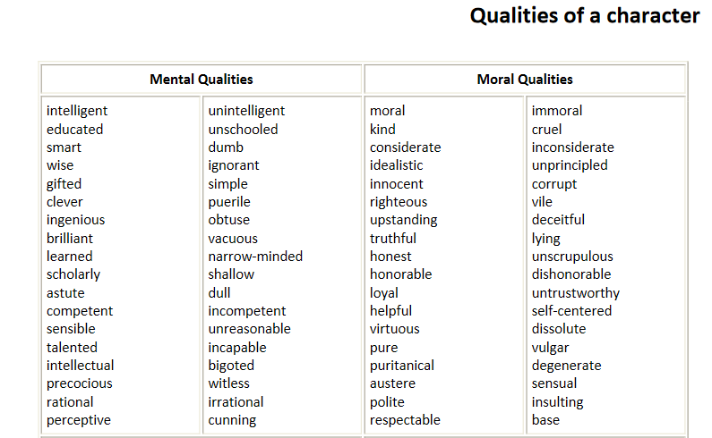

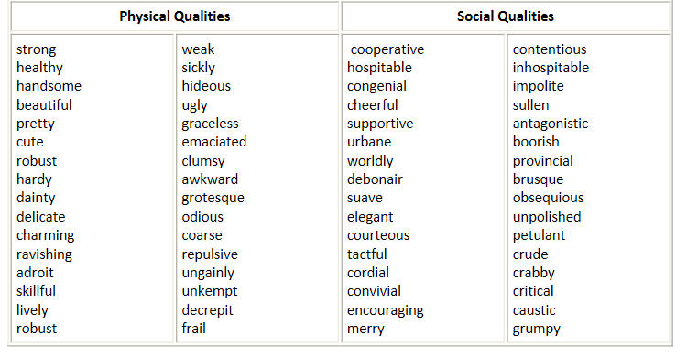

**Forms of literature  
Poetry**  
A poem is commonly defined as a composition written in verse

**Drama**  
A play or drama offers another classical literary form that has continued to evolve over the years. It generally comprises  
chiefly dialogue between characters, and usually aims at dramatic / theatrical performance (see theatre) rather than at  
reading.

Essays  
An essay consists of a discussion of a topic from an author's personal point of view, exemplified by works by Francis Bacon  
or by Charles Lamb.  
**Prose fiction**Prose consists of writing that does not adhere to any particular formal structures (other than simple grammar); "non‐  
poetic writing," writing, perhaps.

Narrative fiction (narrative prose) generally favours prose for the writing of novels, short stories, graphic novels, and the  
like.